Conversion of general tree to binary tree

Rules:
- Root of general tree= root of binary tree
- Leftmost child of the node in general tree = left child of node in binary tree
- Right sibling of the node in general tree = right child of node in binary tree

Example 1:

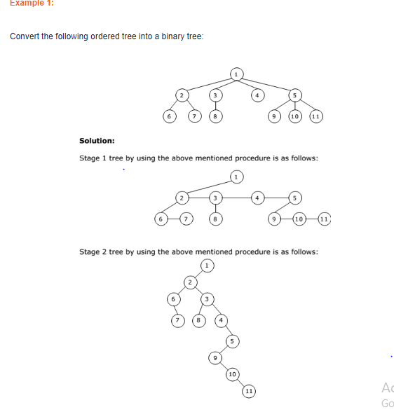

Example 2
